INPUT FOR PROJECT 1:-

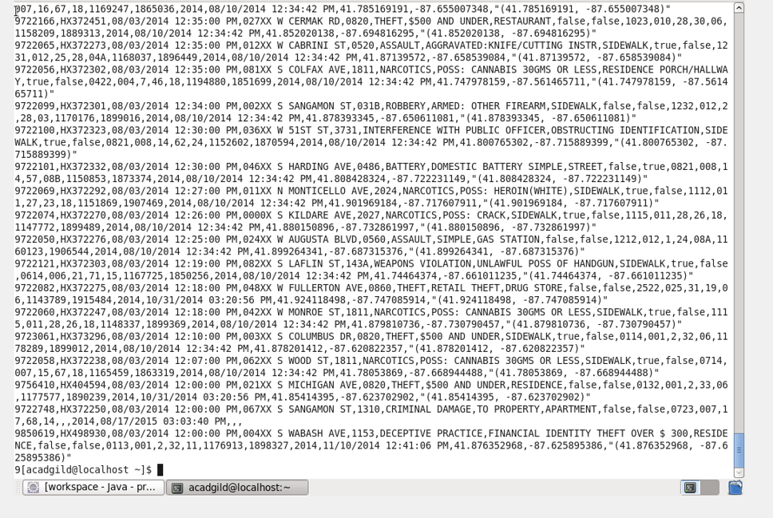

PROJECT 1:-

PROBLEM 1:-

SOLUTION BY PIG:-

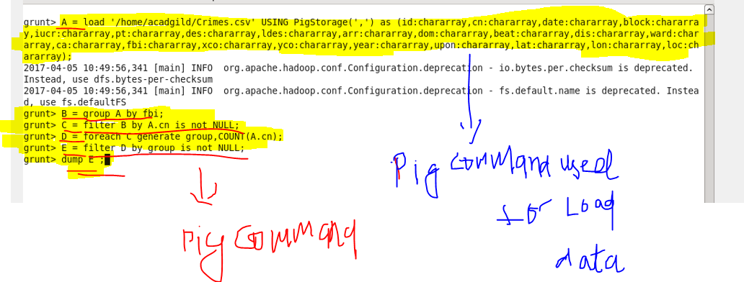

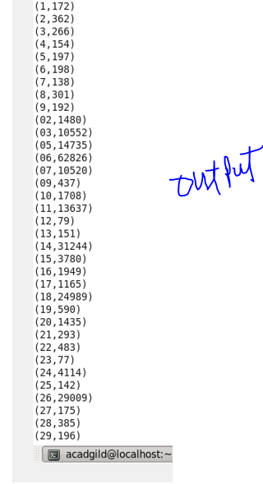

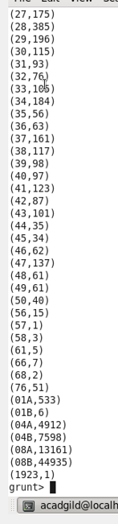

SOLUTION BY MAPREDUCE:-

DRIVER CLASS:-

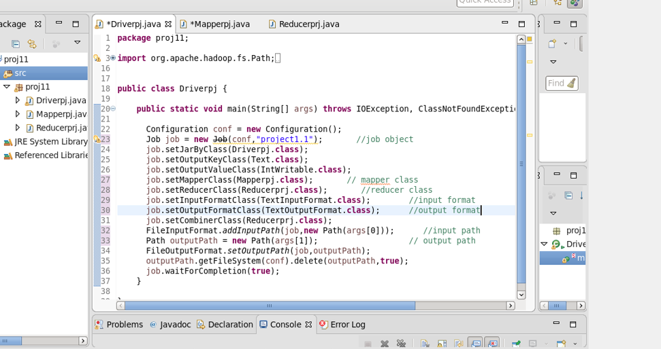

REDUCER CLASS:-

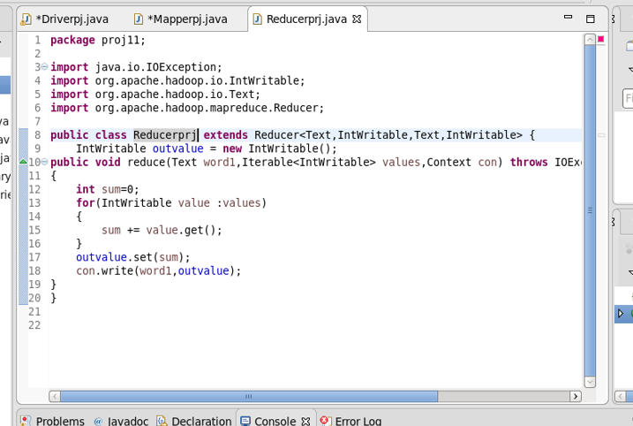

**THE DRIVER AND REDUCER CLASS WILL BE SAME FOR ALL 4 PROBLEMS SO I HAVE ATACHED ONLY MAPPER AND OUTPUT FOR REST OF PROBLEMS**

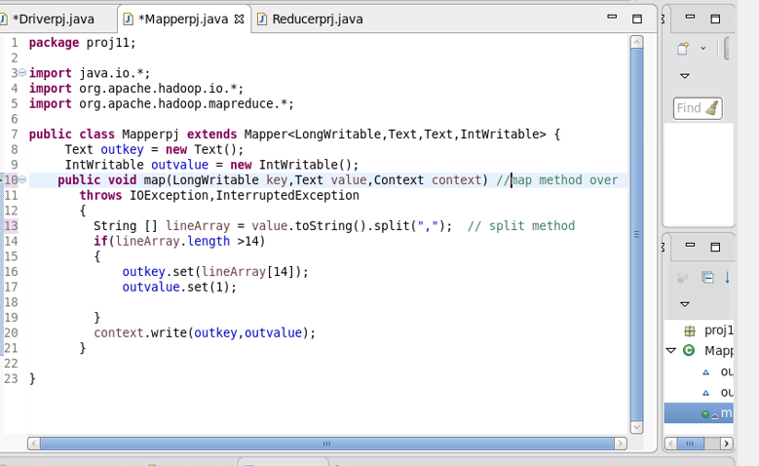

**OUTPUT MAPPER:-**

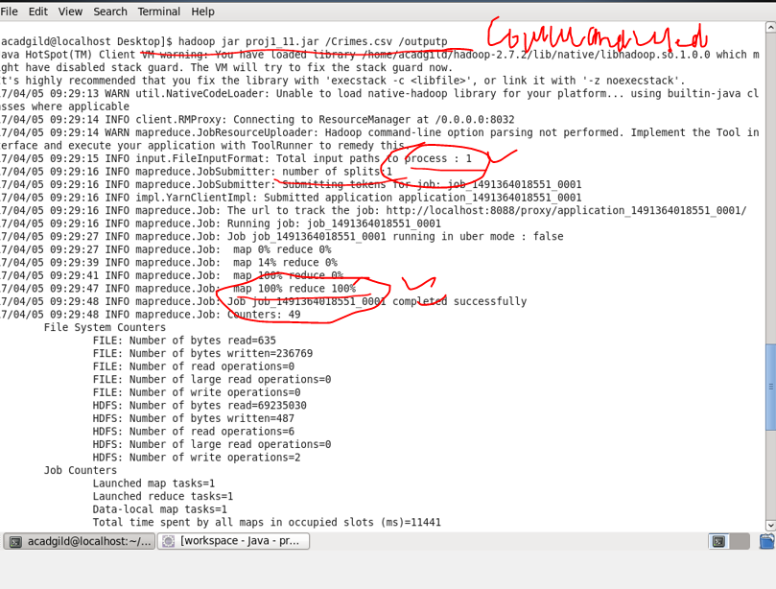

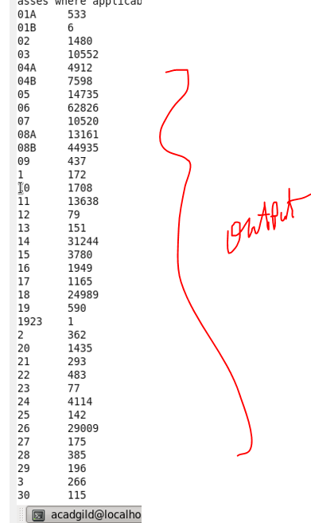

**PROBLEM 2:-**

**SOLUTION BY PIG:-**

**PIG PROGRAM:-**

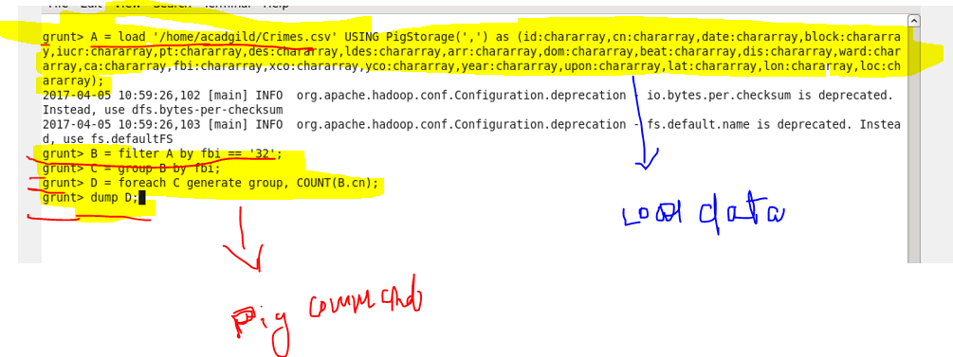

**PIG OUTPUT:-**

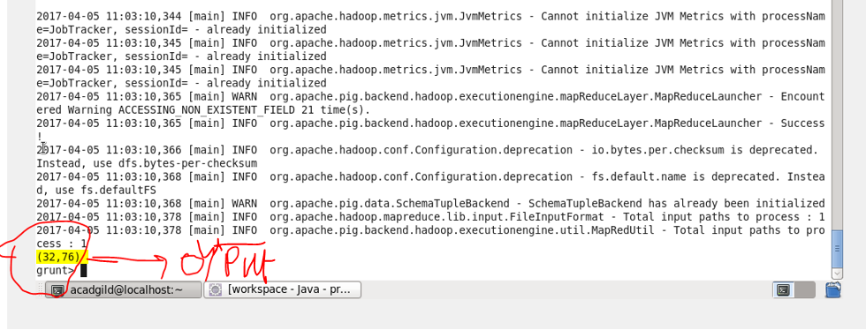

**SOLUTION BY MAPPER :-**

**MAPPER PROGRAM:-**

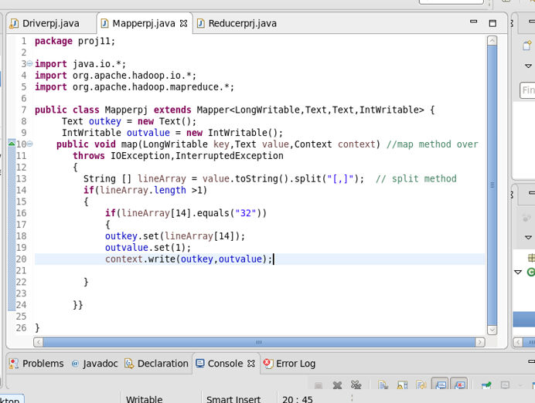

**OUTPUT BY MAPPER:-**

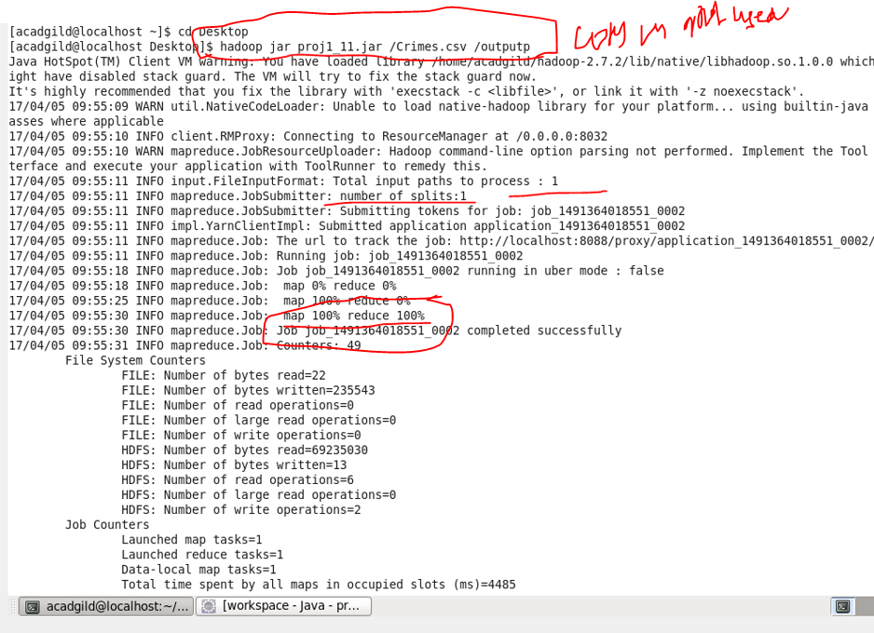

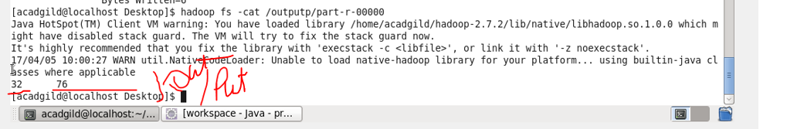

**PROBLEM 3:-**

**SOLUTION BY PIG:-**

**PIG COMMANDS:-**

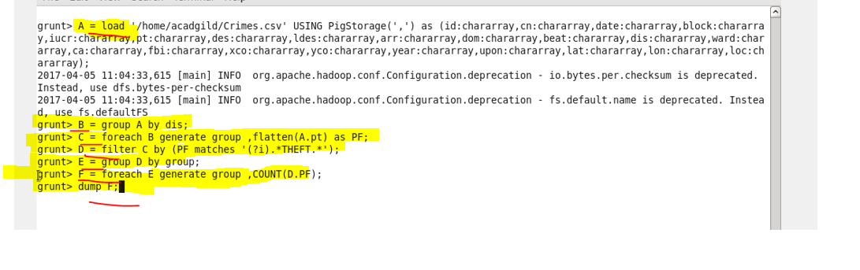

**PIG OUTPUT:-**

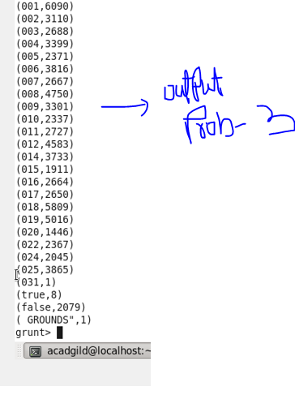

**SOLUTION BY MAPPER:-**

**MAPPER CLASS:-**

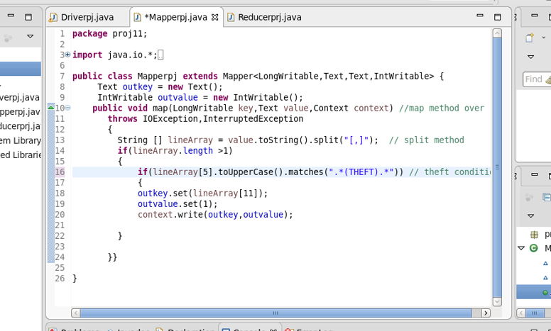

**OUTPUT MAPPER:-**

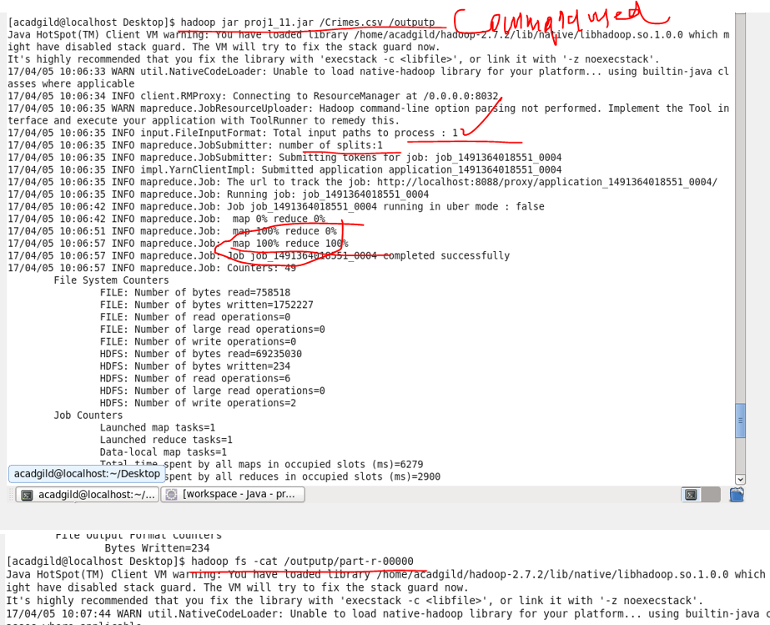

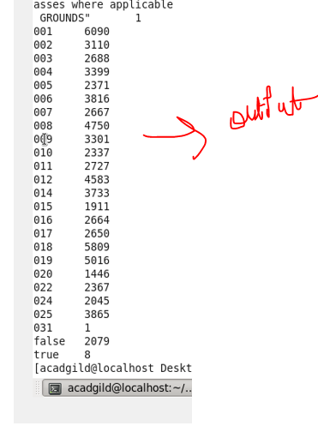

**PROBLEM 4:-**

**SOLUTION BY PIG:-**

**PIG COMMANDS:-**

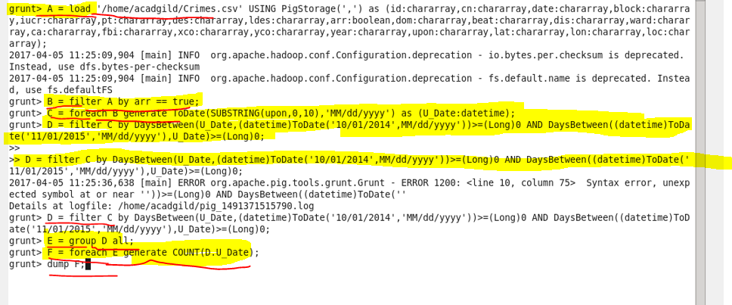

**PIG OUTPUT:-**

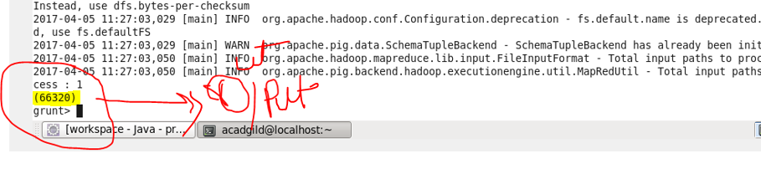

**SOLUTION BY MAPPER:-**

**MAPPER CLASS:-**

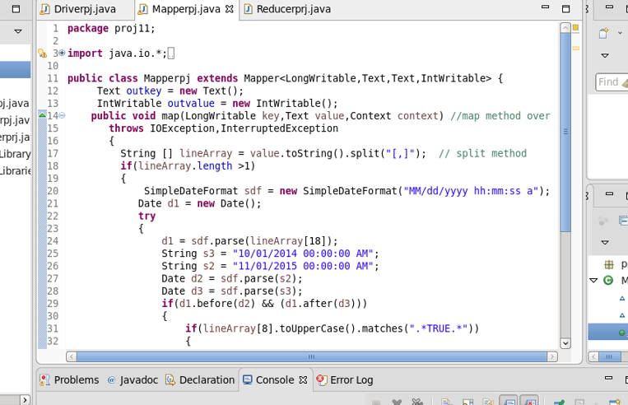

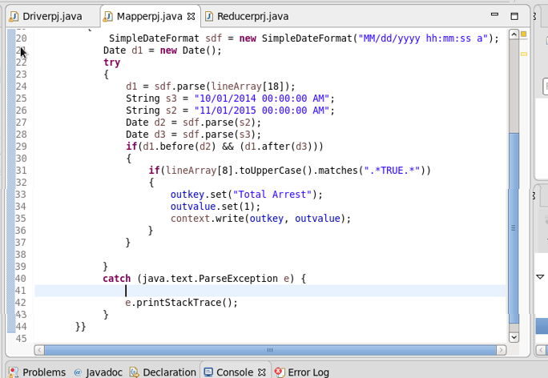

**OUTPUT MAPPER:-**

